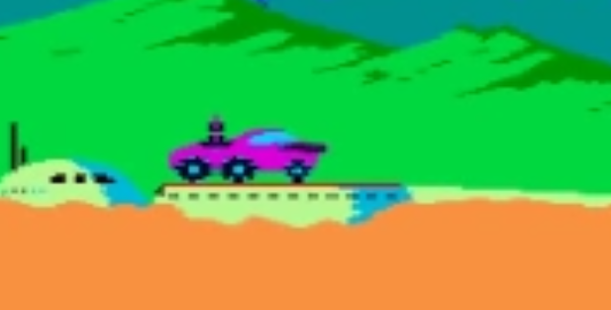

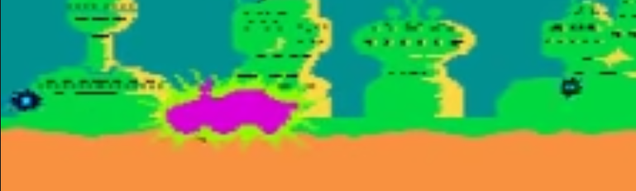

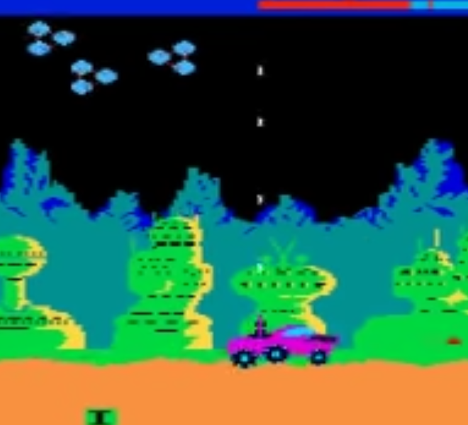

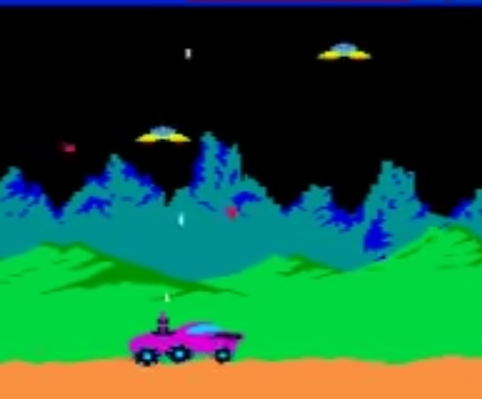

**Pick-ups**

* Extra-life
* Special weapons
  + Multi-shot
  + Seeker-Missiles
* Shields
* Rocket jump

**Levels**

* 3 levels
* Loading Screen
* Dead Screen
* Win Screen

**Environments**

* Mountains
* Volcanos – use particle system
* Trees?
  + Some alien trees
  + Rock formations
* Moons
* Planets
* Starfield
* Platforms

**VFX**

* Explosions – particles
* Shields
* Lasers
* Rockets

**Enemies**

* General saucer
* Scout saucer
* Heavy bomber
* Mothership

**Music**

**SFX**

* Menu Selection
* Game Start
* Buggy
  + Engine idle
  + Engine slow
  + Engine accelerate
  + Front gun
  + Top gun
  + Missiles
  + Shields on
  + Shields off
  + Explode / dies
* Enemies
  + General saucer
    - Flying
    - Shooting
    - Exploding
  + Scout
    - Alert sound?
    - Flying
    - Doesn’t shoot?
    - Drops a random power up

**Things to figure out**

* Platform collisions
* Enemy collisions